Registration Form
Latest Investigations, Repair & Rehabilitation
Technologies for Dams

Name (Mr./Ms./Dr./Prof./Er.).: ……………………………………………………………………………………………..
Organization: …………………………………………………………………………………………………………………………
Designation: ………………………………………………………………………………………………………………………….
Address: ………………………………………………………………………………………………………………………………..
City: ………………………………………… State: …………………………………….. Pin Code: …………………………
Ph (0): ……………………………… Ph (R): ……………………………… Mobile: ………………………………………….
Email 1: ………………………………………………………… Email 2: ………………………………………………………..
Mode of Payment: DD No. ……………………………… Bank: ………………………………………………………….
GST Number: …………………………………………………………

Online Transfer Details:
Name of the Bank: ICICI Bank Ltd
Address of the Bank: ICICI Bank, 9 A, Phelps Building, Connaught Place, New Delhi-110001 Name of the Account holder: AQUA FOUNDATION
A/C No.: 000701260885
IFSC Code: ICIC0000007
Swift code: ICICI NBB CTS

Fee Structure:
Government Departments, Ministries | INR 8,000 per participant
Private, PSUs, Boards | INR 12,000 per participant
Students, Research Scholars | INR 6,000 per participant

• GST will be charged extra as applicable (present rate of GST is 18%).
• In case of multiple registrations same form to be photocopied.

Contact Details:
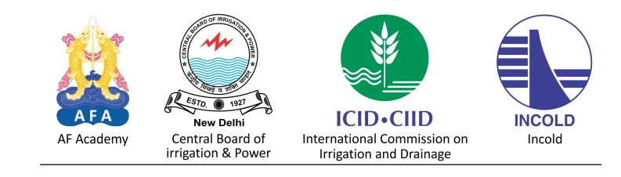
Secretary General, Dam Safety Secretariat
E-166, 2nd Floor, Kalkaji, New Delhi-110 019, India
Mobile: +91-9818568825, +91-9873556395
Email: dams@damsafety.co
Website: www.damsafety.co

